Centre 51619

Candidate examination handbook
2023/24

Contents
Introduction 4
Contacts 4
Exam regulations/ Malpractice 4
Personal data 4
Non-examination assessments, NEAs, and coursework 5
Timetabled written exams 5
Contingency day - Summer 2024 5
Exam timetable clashes 5
Where you will take your exams 6
What time your exams will start and finish 6
Supervision during your exams 6
Exam room conditions 6
Where you will sit in the exam room 7
What equipment you need to bring to your exams 7
Using calculators 7
What you must not bring into the exam room 7
Food and drink in exam rooms 7
What you should wear for your exams 8
Where your personal belongings will be stored during your exam 8
What to do if you arrive late for an exam 8
What to do if you are unwell on the day of a public exam 8
Special consideration 8
What happens if you have an unauthorised absence from an exam 9
What happens in the event of an emergency in the exam room 9
Candidates with access arrangements 9
Results 9
Post-results services 9
Certificates 10
Appendix 1: JCQ Information for candidates – Written examinations 11
Appendix 2: JCQ Information for candidates – Privacy notice 15
16
17
Appendix 3: JCQ Information for candidates – Social media 18
Appendix 4: JCQ Unauthorised Items poster 19
Appendix 5: JCQ Warning to Candidates poster 20
Appendix 6: JCQ Preparing to sit your exams 21

Introduction
The aim of this handbook is to brief you on the public examination and assessment process in place in The Holt School and make you aware of the required JCQ regulations and information for candidates.

Contacts
Exam officer: Mrs H Cross h.cross@holt.wokingham.sch.uk
School website: https://www.holtschool.co.uk/parent-information/exam-information where you can find:
- Dates and timetables
- Results days
- Information about post results services
- Exam boards and qualification codes
- JCQ information for candidates
- Information about certificates

Exam regulations/ Malpractice
All candidates must read the following:
JCQ Information for candidates – Written examination (See Appendix 1)
JCQ Information for candidates – Social media (See Appendix 3)
JCQ Unauthorised Items poster (See Appendix 4)
JCQ Warning to candidates poster (See Appendix 5)
Breaking any of the JCQ regulations could lead to loss of marks or even disqualification from all exams and the school must investigate and report any breaches of regulations to the exam board.
Malpractice means any act or practice which is in breach of the JCQ regulations. This can include:
- Bringing unauthorised material into the exam room e.g., mobile phones, watches, revision notes, AirPods, earphones/earbuds
- Not following exam conditions in the exam room e.g., communicating in any way with another candidate
- Copying or allowing work to be copied e.g., posting written work on social networking sites prior to an exam or assessment
- Allowing others to help produce your work or helping others with theirs

Personal data
The exam boards collect information about exam candidates. To understand what information is collected and how it is used, you must read:
Appendix 2: JCQ Information for candidates – Privacy notice (See Appendix 2)

Non-examination assessments, NEAs, and coursework
NEAs and coursework are assessments that take place outside of the written examination series. They include language speaking tests, practical and performance units.

If you are taking: | You must read:
GCSE subjects: art, dance, graphics, textiles, product design, drama, English speaking, French speaking, Spanish speaking, food and nutrition, music, physical education  GCE subjects: art, product design, English literature, geography, history, physical education, French speaking, Spanish speaking | JCQ Information for candidates: Non-examination assessments
CAMNAT child development, health and social care  GCE AS extended project | JCQ Information for candidates: Coursework

Your teacher will tell you the dates and times of your assessments. You will be told if your work will be marked by your teacher or by the exam board. If your teacher has marked your work, you will be told your mark and you have the right to request a review of the centre assessed mark before it is submitted to the exam board for moderation. If you have concerns about the procedures used in assessing your work or with the mark given you should see Mr Adams, Assistant Head, immediately.
Information about appeals and deadlines can be found in the Internal Appeals Procedure (See Exams policy: Appendix 1). An appeal must be submitted in writing within 7 calendar days of receiving your centre assessed marks.

Timetabled written exams
When you receive your Statement of Entry in January, you must check carefully that your personal details and exam entries are correct. Your registered legal name must be used for examinations as this will appear on your certificates. You must correct any errors on the sheet and return to the exam office by the deadline.
When you receive your timetable, you should make a note of the dates and times of all your exams as well as the rooms and seat numbers. If you miss a public examination, you cannot take it at another time.

Contingency day - Summer 2024
Contingency afternoons: 6th and 13th June. (All candidates must be available then in case of a national or local disruption to the examination series)
Contingency day 26th June. (All candidates must be available until this date in case of a national or local disruption to the examination series.)

Exam timetable clashes
You may have a clash where two papers or more are timetabled at the same time. There are three types of clash:
- A false clash, where the exam board schedules two papers in the same subject to be taken one after the other, e.g. MFL listening and reading papers
- A back-to-back clash, where there are two different subjects scheduled at the same time with a total time of up to three hours. The regulations state that these must be held in the same session. The exam officer will select the order of the exams and this will be shown on your timetable. You may have a short break between the exams, but you must stay under exam conditions in the exam room and cannot revise.
- A session rearrangement, where there are two or more different subjects and the total time is more than 3 hours. One subject may be moved to the other session on the day or the three exams will be scheduled throughout the day at staged intervals. In this case the exam officer will contact you to explain what will happen and you will be supervised by an invigilator between exams to maintain the security of the exams.

Where you will take your exams
The main exam rooms are the Hall and the Gym, although some students may take exams in classrooms and students with some access arrangements in Holt House.

What time your exams will start and finish
At The Holt School:
Morning exams start at 9.00am
Afternoon exams start at 1.00pm
If you finish your exam early, you must stay in the exam room until the exam finishes. You cannot leave until the invigilator tells you. If your afternoon exam is shorter than 90 minutes you will have to stay in your seat until 2.30pm. During this time, you must remain quiet and not disturb other candidates.

Supervision during your exams
At The Holt School exams are supervised by a team of invigilators. Invigilators must follow strict rules and regulations when conducting exams as directed by JCQ awarding bodies etc.
They will distribute and collect the examination papers, tell candidates when to start and finish the examination, hand out extra answer sheets and deal with any issues that occur during the examination e.g. illness of a candidate.

Exam room conditions
- Once you enter the exam room you are under exam conditions and must remain silent
- Do not start to write anything until the invigilator tells you to fill in the details on the front of your question paper or answer book.
- Do not open your paper until you are instructed that the exam has begun.
- Listen carefully to instructions and notices read out by the invigilators – there may be amendments to the exam paper that you need to know about.
- Check you have the correct question paper – check the subject, paper, and tier of entry
- Read all instructions carefully
- If a subject has a choice of questions, ensure you put the QUESTION NUMBER in the space indicated.
- Your registered legal name must be used on your examination papers.
- If you drop something on the floor do NOT pick it up - please put your hand up clearly and an invigilator will come to you.
- You will not be allowed to leave an examination room early. If you have finished the paper use any time remaining to check over your answers and that you have completed your details correctly.
- When told to do so stop writing immediately.
- At the end of the examination all work must be handed in – remember to cross out any rough work. Make sure your name is on all additional answer sheets.
- Invigilators will collect your exam papers and other examination material before you leave the room. Absolute silence must be maintained during this time. Remember you are still under examination conditions until you have left the room.
- Question papers, answer booklets and additional paper must NOT be taken from the exam room.
- Remain seated in silence until told to leave the examination room.
- Please leave the room in silence and show consideration for other candidates who may still be working. Please be aware that other rooms may be in use and be silent.

Where you will sit in the exam room
Your timetable will show rooms and seat numbers. If you forget your seat number, you can ask the teacher who is registering you. The seating plan is subject to change so you will be informed as you enter if it has changed.

What equipment you need to bring to your exams
Make sure you all have your own equipment. In an emergency, it may be possible to borrow limited items from the invigilators. Your pencil case must be clear, and all contents must always be visible to the invigilator. You must bring the following with you:
- minimum of 2 pens – black only
- 2 HB pencils
- Ruler (marked with millimetres)
- Pencil sharpener
- Eraser
For certain exams you will also need the following:
- Calculator (without the lid)
- Compasses
- Protractor
- Coloured pencil crayons
Pens should be black ballpoint. Erasable pens and gel pens are not permitted as these may be erased by the scanning process. Correction pens/fluids are NOT allowed. Highlighters MUST NOT be used in your answers but may be used on question papers.

Using calculators
Check with your teacher well in advance of the examination date that yours conforms to regulations.
Calculators with a memory function must be cleared before entering the exam room.
Calculators must be free of lids or cases.

What you must not bring into the exam room
Only material listed on the question paper is allowed in the exam room. You must not have on you or near you any other material. You must not have notes, an iPod, an MP3/4 player or similar device a watch, AirPods, earphones/earbuds. If you find you have any unauthorised items, you must hand them to an invigilator before the exam starts. Failure to do so will be reported to the exam board and will be subject to penalty and possible disqualification.

Food and drink in exam rooms
No food is allowed in the exam room.
Water bottles are permitted but MUST be transparent and have a spill proof lid. There must be no writing or labelling on the bottle.

What you should wear for your exams
KS4: should wear school uniform
KS5: should follow the sixth form dress code – no hoods or outdoor coats

Where your personal belongings will be stored during your exam
Only authorised items are allowed in the exam room, you should leave all bags, coats, phones, watches etc in your locker.

What to do if you arrive late for an exam
You should make every attempt to arrive in plenty of time to register before your exam. However, if you know you are going to be late, due to unavoidable circumstances, then you must contact reception, who will inform your head of year and the exam officer.
A candidate who arrives within 30 minutes after the start of the exam will be allowed to sit the exam and will be allowed the full time.
You should register at student support and then go to the exam room, where the invigilator will start your exam and inform the exam officer of your arrival.

What to do if you are unwell on the day of a public exam
If you are unwell on the day of a public exam you must email examabsence@holt.wokingham.sch.uk as soon as possible and by 8.00am at the latest.
Please give your name and tutor group, a contact number and any other relevant information.
A member of the Senior leadership team or Head of year will call you back and advise you of the next steps.
Please note that it is not possible for school to reschedule public examinations that are missed for any reason.
Candidates who have not notified school and are absent when the attendance register is completed will be contacted by student support as to their whereabouts.
School cannot give advice on whether a candidate is fit to take an examination, but it may be possible for temporary access arrangements to be put in place, such as separate invigilation, rest breaks. The head of year will discuss this with the exam officer and SENCo.
If a candidate is unable to attend the exam for an acceptable reason and school can verify this, then special consideration will be applied for.
JCQ Form 14 Self Certification form should be completed when school cannot verify a candidate’s illness.

Special consideration
If your performance in an exam or assessment is affected by adverse circumstances beyond your control e.g. temporary illness, accident/ injury, bereavement, or domestic crisis, then school may make an application for special consideration. To support the application, you must complete a special consideration form (available from the exam office) with the dates of the exams affected and details of the adverse conditions affecting your performance. You should attach any medical evidence such as a doctor’s note, copy of a prescription or hospital appointment etc.
You must see also your head of year either before the exam or immediately after so that a record can be made.
The exam officer will make the application and if it is approved by the exam board, they will only make a minor adjustment to the mark awarded as larger adjustments would jeopardize the standard of the examination.

What happens if you have an unauthorised absence from an exam
If a candidate misses an exam and has no acceptable reason, then the head-teacher may decide to withdraw them from the qualification.

What happens in the event of an emergency in the exam room
In the event of an emergency in the exam room e.g. fire bell, containment bell or illness of another candidate, you should remain in your seat and follow the invigilators instructions.

Candidates with access arrangements
The SENCo will identify and inform candidates who are eligible for access arrangements. The type of arrangement may determine where you are seated in the exam room.
If you have extra time, you will have a yellow card on your desk and can continue to work until the time shown on the board or on the card
If you have rest breaks you will have a blue card on your desk. If you need a break, you should raise your hand to alert an invigilator.
If you use a word processor you will be accompanied by the invigilator at the end of the exam, to the exam office to print off your work.
If you think you have not been given the correct access arrangement, you should inform an invigilator before the exam starts and they will check with the exam officer.

Results
Students will be emailed results on results days. Dates and times will be published on the school website.
Summer 2024 results days:
GCE 15th August
GCSE 22nd August

Post-results services
If your result is very different from what you were expecting, you can request to see your exam script or even have your exam marking reviewed.
A form with details of fees and deadlines will be available to download from Wisepay.
SLT will be available in school on results days to discuss results with candidates.
Students wishing to apply for a post results service must complete the form giving their consent and make the payment before the deadline. Remember results can go down as well as up.
The exam officer will submit the application to the exam board and the outcome will be emailed to the candidate.

Certificates
Certificates must be collected in person and signed for at Reception after 1st December.
If you are unable to collect in person, you must email the Exam officer to give permission for someone to collect and sign on your behalf.
It is very important to collect your certificates and look after them carefully, as you will need them in the future and replacements are very expensive and difficult to obtain. The Holt School is not obliged to retain certificates after a year and unclaimed certificates may be destroyed or returned to the exam board.

Appendix 1: JCQ Information for candidates – Written examinations

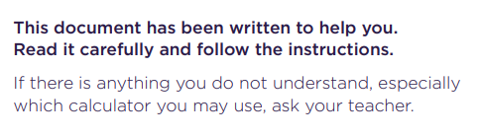
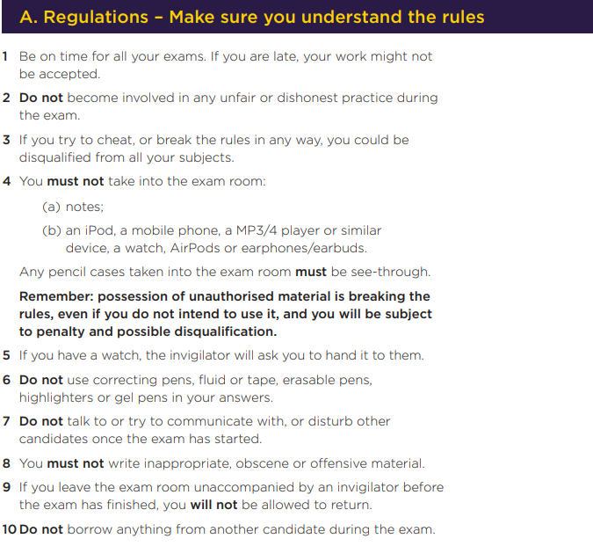

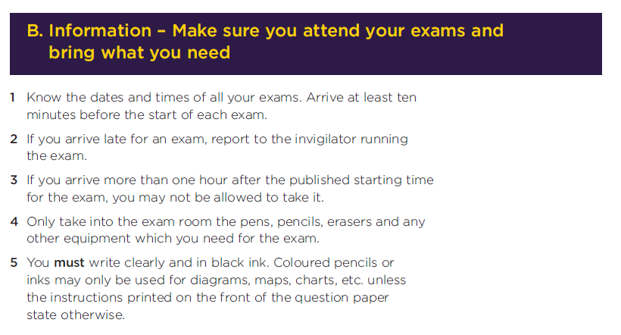
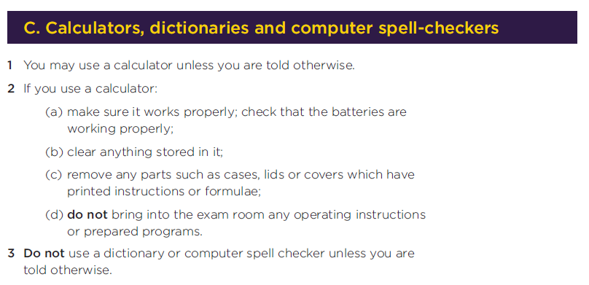
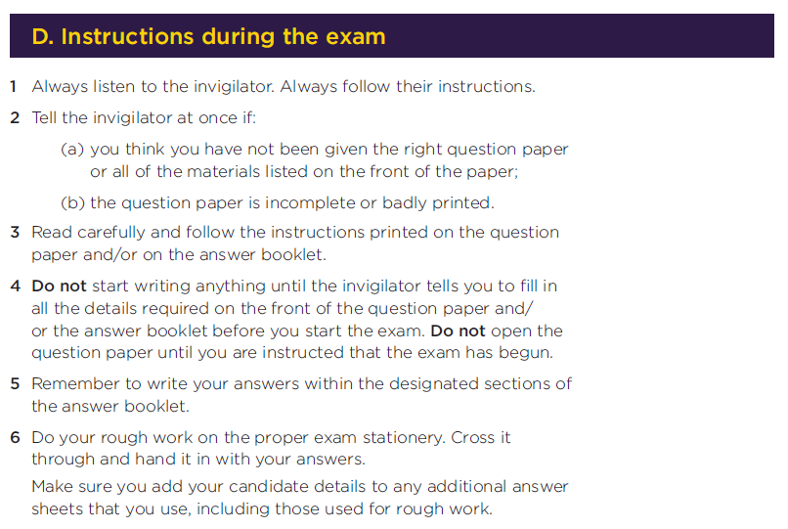
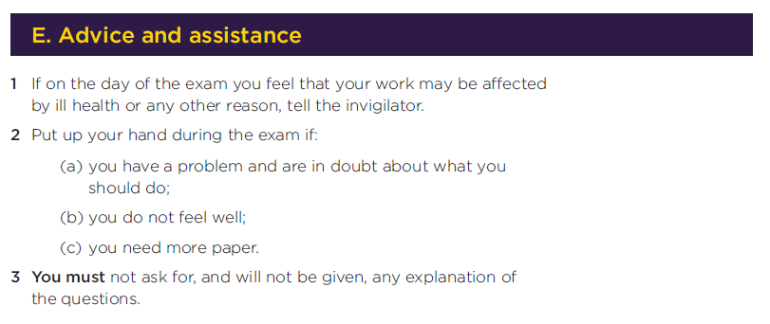

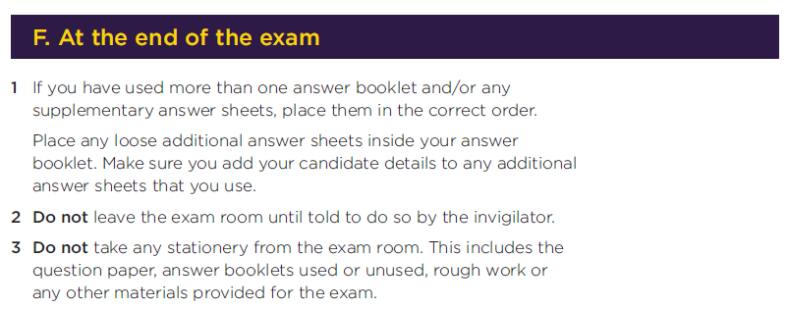

Appendix 2: JCQ Information for candidates – Privacy notice
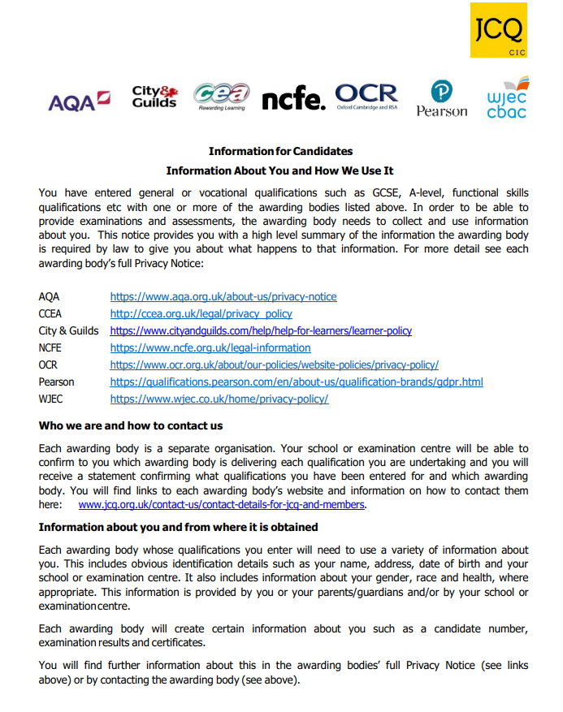

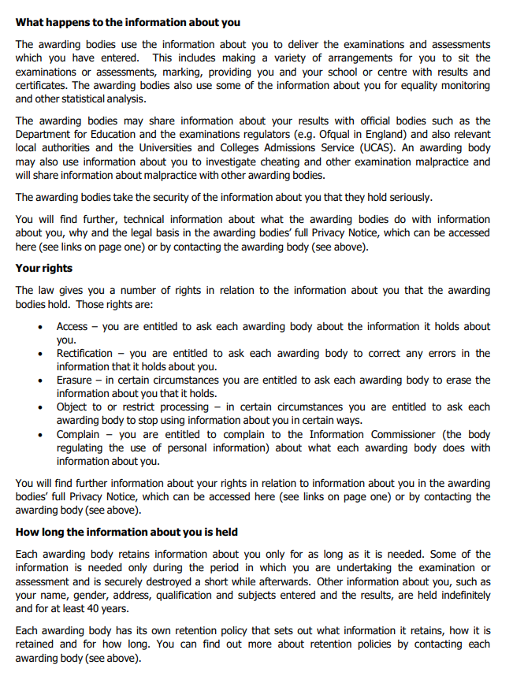

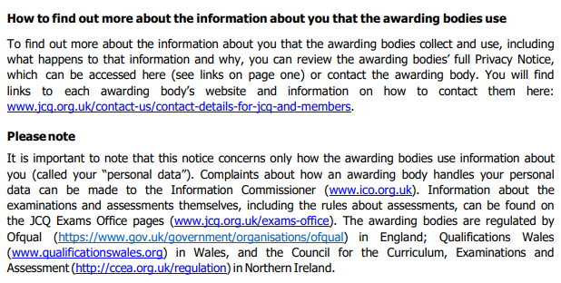

Appendix 3: JCQ Information for candidates – Social media

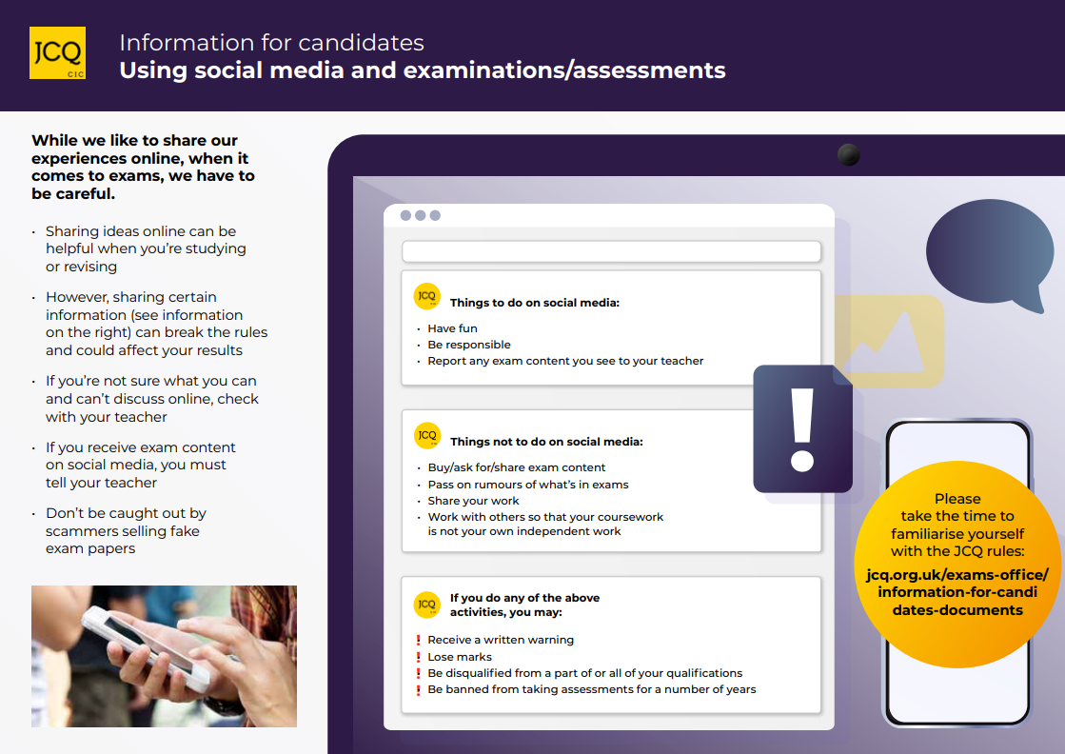

Appendix 4: JCQ Unauthorised Items poster

Appendix 5: JCQ Warning to Candidates poster
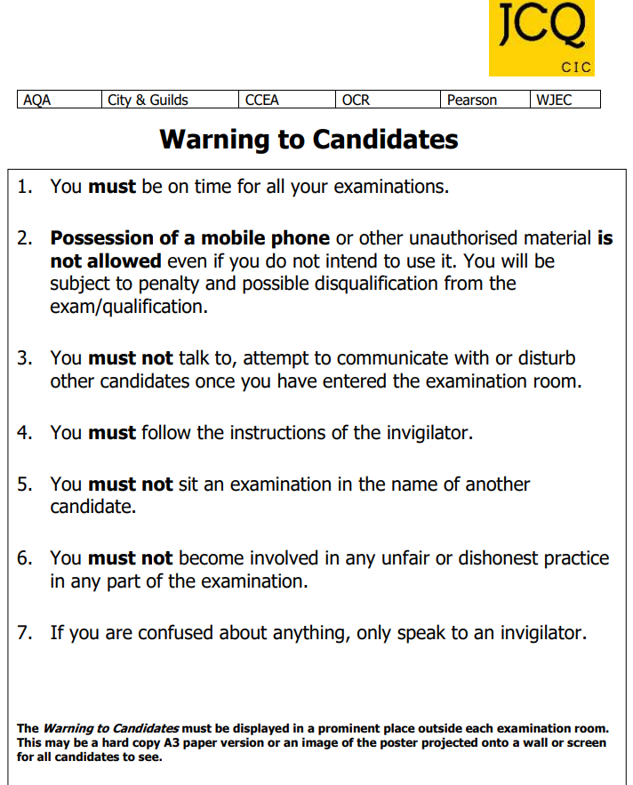

Appendix 6: JCQ Preparing to sit your exams

